**ReactJS**

**HandsOn**

**2.Home.js**

import React, { Component } from 'react';

class Home extends Component {

  render() {

    return (

      <div>

        <h3>Welcome to the Home Page of Student Management Portal</h3>

      </div>

    );

  }

}

export default Home;

**About.js**

import React, { Component } from 'react';

class About extends Component {

  render() {

    return (

      <div>

        <h3>Welcome to the About Page of Student Management Portal</h3>

      </div>

    );

  }

}

export default About;

**Contact.js**

import React, { Component } from 'react';

class Contact extends Component {

  render() {

    return (

      <div>

        <h3>Welcome to the Contact Page of Student Management Portal</h3>

      </div>

    );

  }

}

export default Contact;

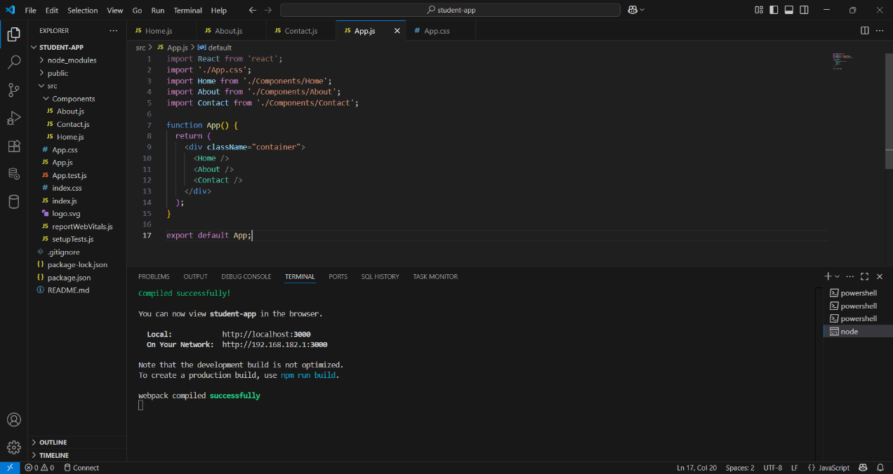

**Output:**

